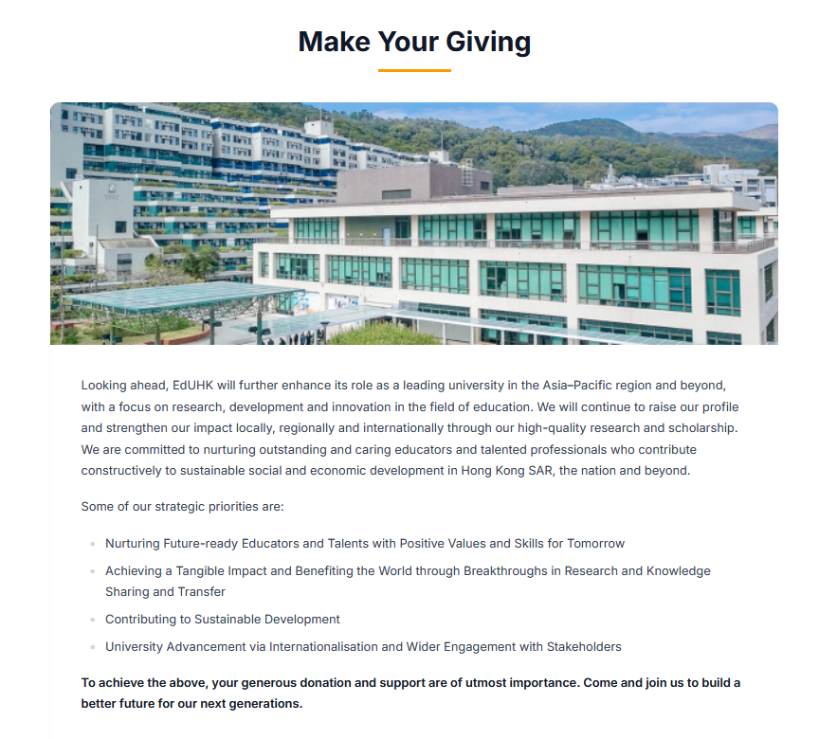_________________________________________________________
Scholarships and Bursaries
EdUHK recognises and supports students who demonstrate academic excellence and outstanding non-academic performance through a wide range of scholarships. We also offer bursaries to support financially needy students.
Explore how you may plant seeds of hope for EdUHK students by becoming our scholarship and bursary donors:
Pamphlet on EdUHK Scholarships and Bursaries

(please create a button for visitors to download the pamphlet)
_________________________________________________________

“Development Tree & Adopt-a-Seat” Programme
The “Development Tree & Adopt-a-Seat” programme is a special way to make public your tremendous support for the University by sponsoring the following items：

Development Tree – Donate a leaf for the Development Tree in the Learning Commons, C-LP-01, to nurture our next generation
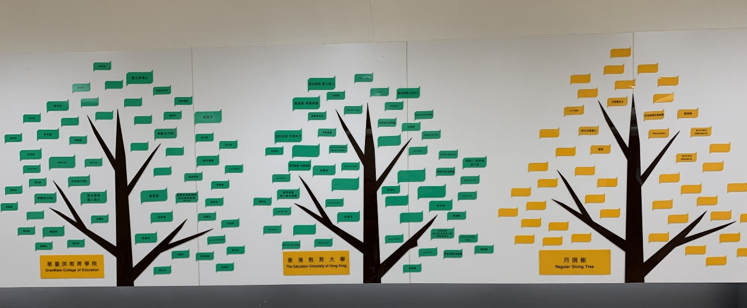
- Large Leaf 144mm (w) x 96mm (h): HK$3,000
- Medium Leaf 120mm (w) x 80mm (h): HK$1,000
- Small Leaf 96mm (w) x 64mm (h): HK$500

Adopt-a-Seat – Donate a chair for the 600-seat lecture theatre, C-LP-11, to give impetus to our teacher training programmes
[Photo of C-CP-11, please leave a space here to insert photo first and we will provide the photo later]
- Row 1-5: HK$10,000
- Row 6-12: HK$5,000

All donations will be used for our further development and to nurture our students. For example, they will help us to:
- establish scholarships to recognise students with outstanding achievements;
- provide bursaries to students with financial needs;
- support students’ whole-person development through student exchange programmes, work placement and service learning opportunities;
- enhance teaching facilities and learning environment;
- boost research capacity and fund campus development projects.
Legacy Giving
EdUHK welcomes confirmed legacy givings while related legal services will not be provided. Please reach out to us if you intend to make such donations.
